**TASK 6.2P**

**CLOUD COMPUTING**

**Controlling Account Access Using IAM**

**Task 1: Explore the users and groups, and inspect policies**

**Steps:**

* **Checked the AWS Region:  
  This ensures you're operating in the correct environment because AWS resources are region-specific.**
* **Explored IAM Users (user-1, user-2, user-3):  
  You inspected each user’s permissions, checked if they were part of any groups, and reviewed their security credentials (such as having a console password for login).**
* **Explored IAM Groups (EC2-Admin, EC2-Support, S3-Support):**
  + **Each group can have permissions via managed policies or inline policies.**
  + **Managed policies are pre-built by AWS and can be attached to many users/groups.**
  + **Inline policies are directly attached to a single group or user.**
* **Inspected Policies Attached to Groups:**
  + **EC2-Support Group: Has the AmazonEC2ReadOnlyAccess policy, allowing only viewing of EC2-related resources.**
  + **S3-Support Group: Has the AmazonS3ReadOnlyAccess policy, allowing only viewing/listing of S3 bucket contents.**
  + **EC2-Admin Group: Uses an inline policy called EC2-Admin-Policy, which allows viewing EC2 instances and the ability to start/stop them.**

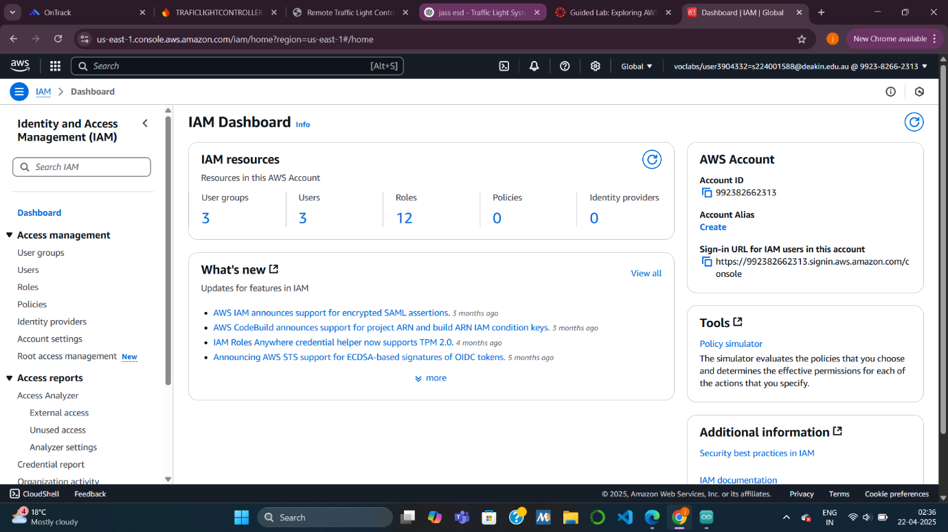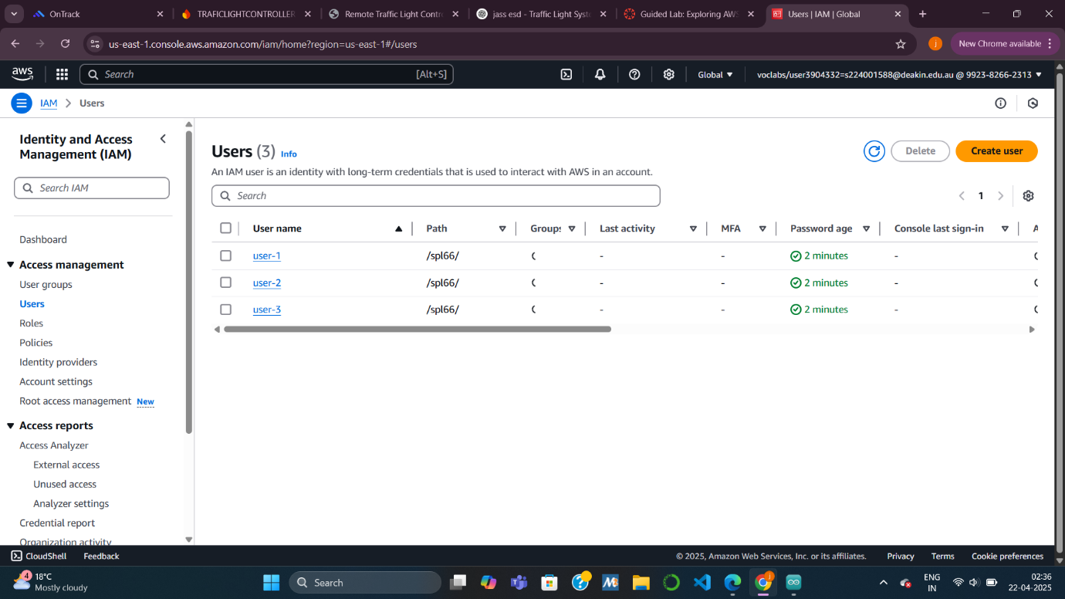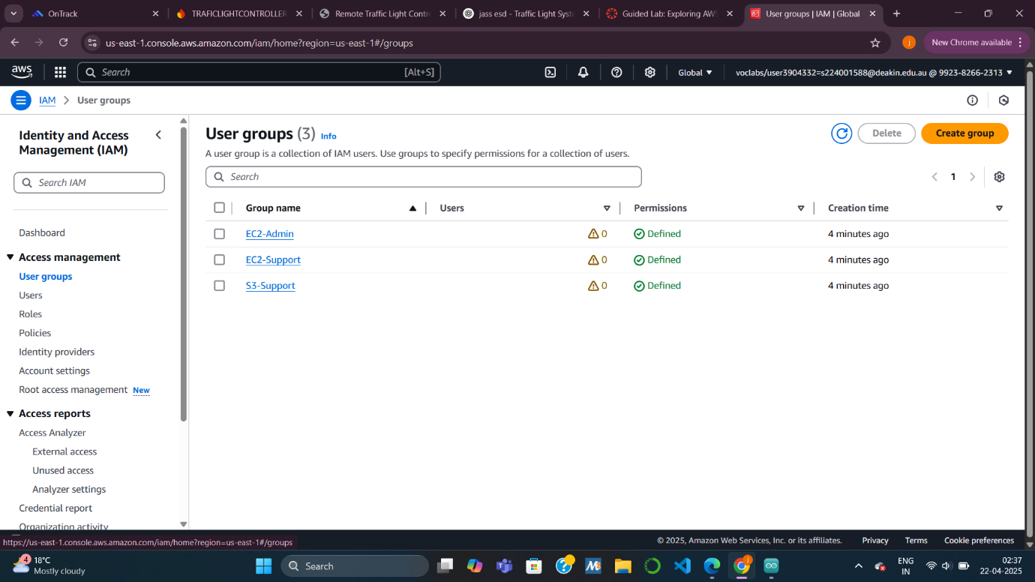

**Task 2: Add users to groups**

**Task 2.1: Add user-1 to the S3-Support group**

* **Why?  
  user-1 is hired as S3 support, so they need permissions to view S3 buckets and objects.**
* **Action:  
  Added user-1 to the S3-Support group, which has the read-only S3 access policy.**

**Task 2.2: Add user-2 to the EC2-Support group**

* **Why?  
  user-2 is assigned to support EC2 services, so they need read-only access to EC2 resources.**
* **Action:  
  Added user-2 to the EC2-Support group, which provides permission to view EC2 instances but not modify them.**

**Task 2.3: Add user-3 to the EC2-Admin group**

* **Why?  
  user-3 is the EC2 administrator, so they require the ability to view, start, and stop EC2 instances.**
* **Action:  
  Added user-3 to the EC2-Admin group, which has an inline policy granting these permissions.**

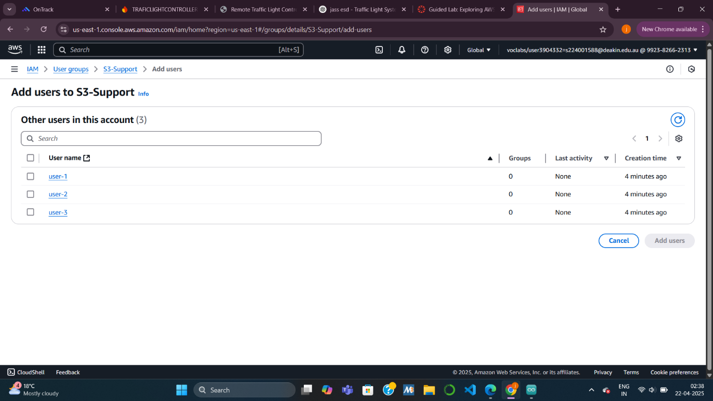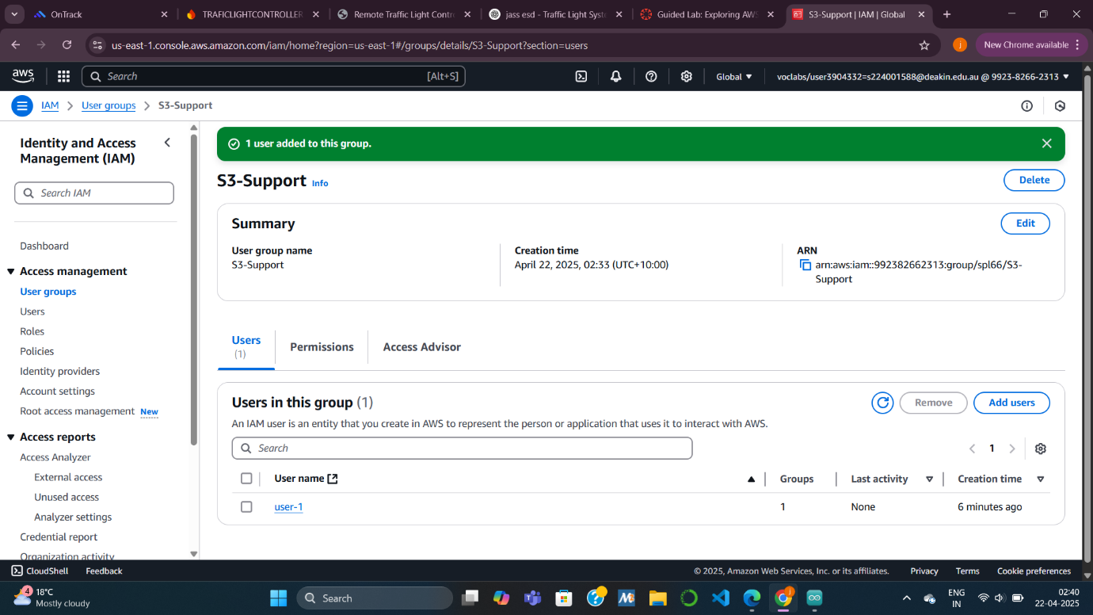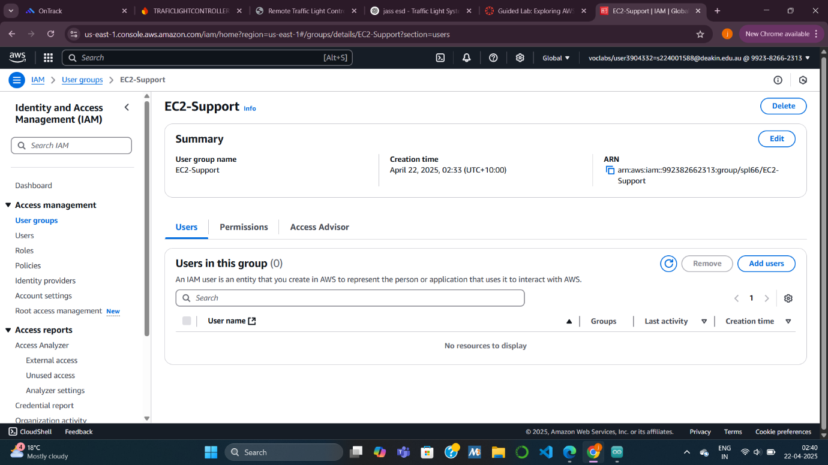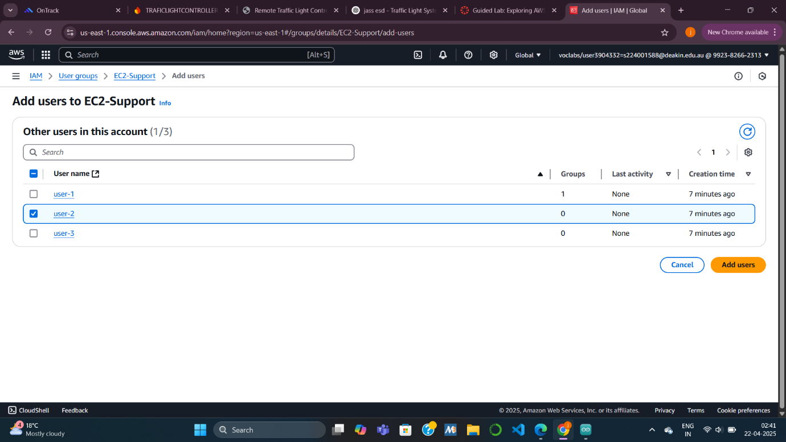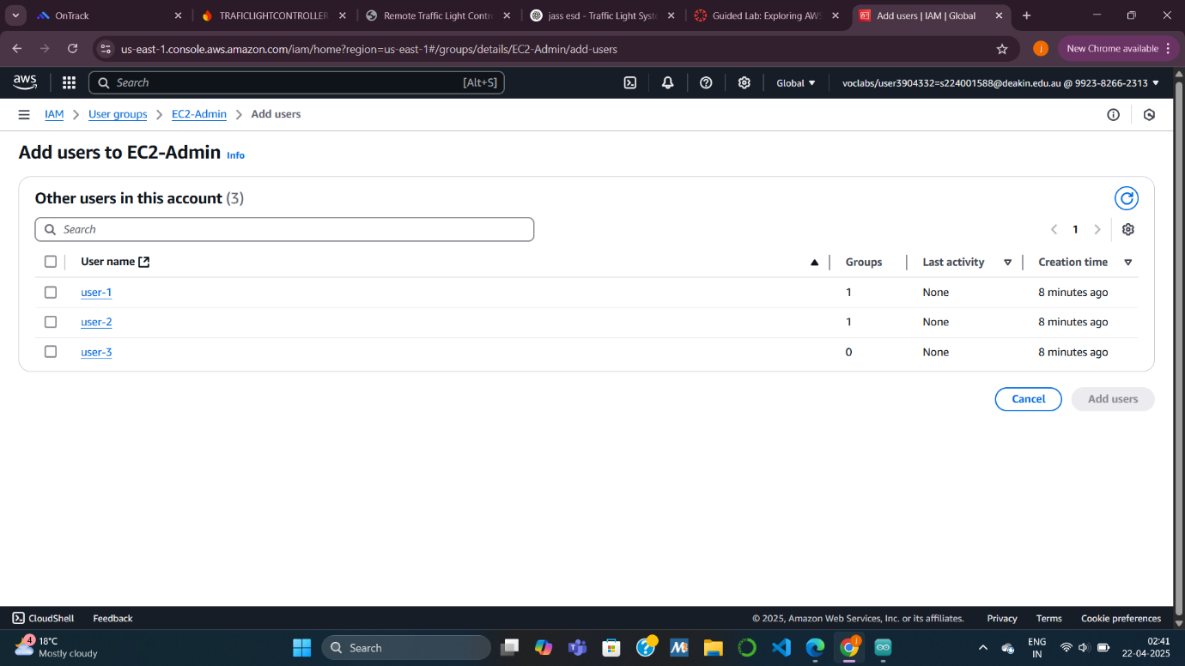

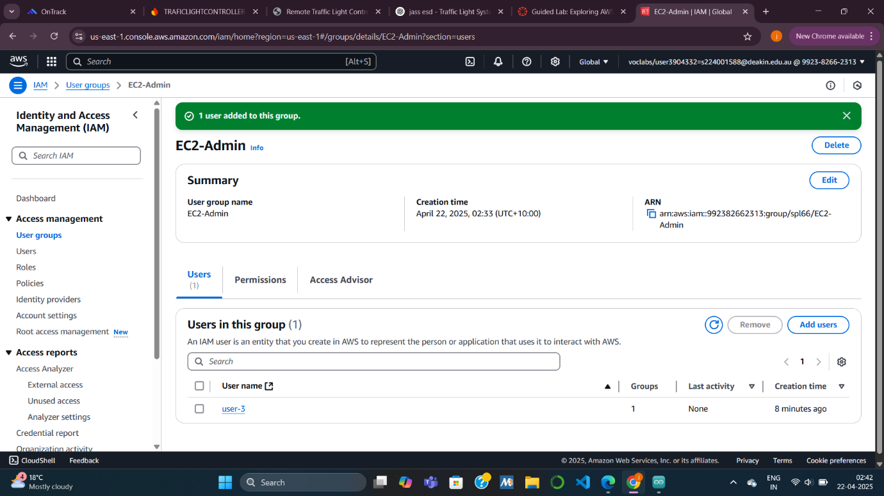

**Task 3: Sign in and test user permissions**

**Task 3.1: Get the Console Sign-In URL**

* **Why?  
  IAM users have a specific sign-in URL to access the AWS console.**
* **Action:  
  Located and copied the IAM sign-in link, which allows you to log in as any of the IAM users created for the lab.**

**Task 3.2: Test user-1 permissions (S3-Support role)**

* **Expected Outcome:**
  + **Can browse S3 buckets and view their contents.**
  + **Cannot access EC2 resources (gets an unauthorized error).**
* **Purpose:  
  Confirms that user-1 has only S3 read-only access through the S3-Support group.**

**Task 3.3: Test user-2 permissions (EC2-Support role)**

* **Expected Outcome:**
  + **Can view EC2 instances but cannot start/stop them.**
  + **Cannot access S3 buckets (gets a permissions error).**
* **Purpose:  
  Verifies that user-2 has read-only access to EC2 only, with no control over S3.**

**Task 3.4: Test user-3 permissions (EC2-Admin role)**

* **Expected Outcome:**
  + **Can view EC2 instances.**
  + **Can start and stop EC2 instances.**
* **Purpose:  
  Confirms that user-3 has the correct administrator privileges for EC2 management.**

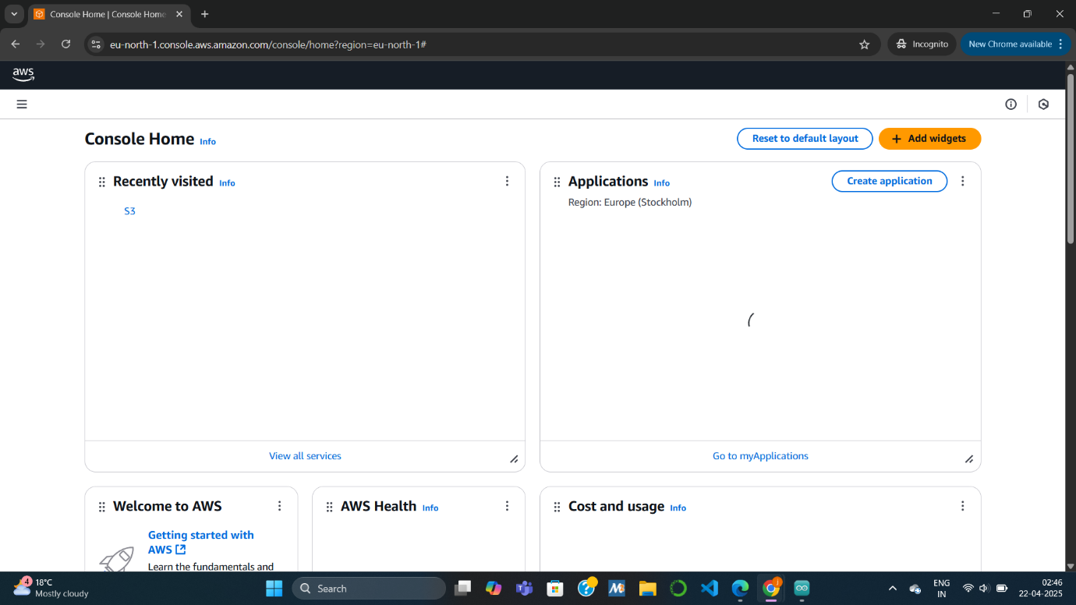

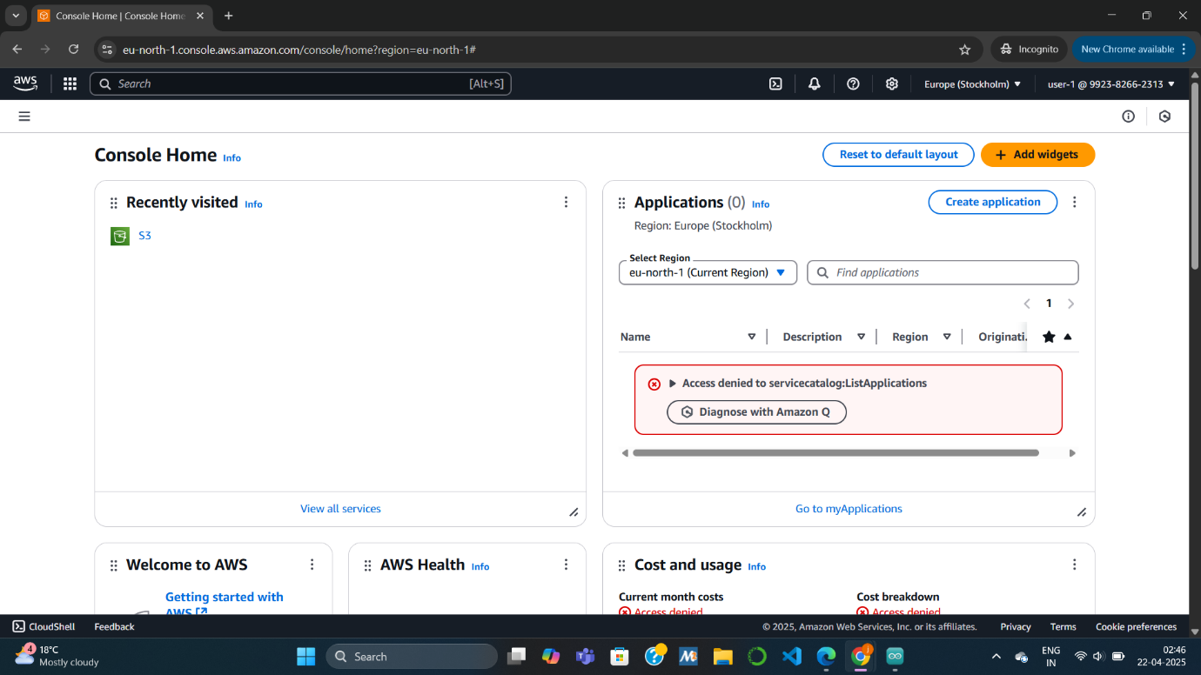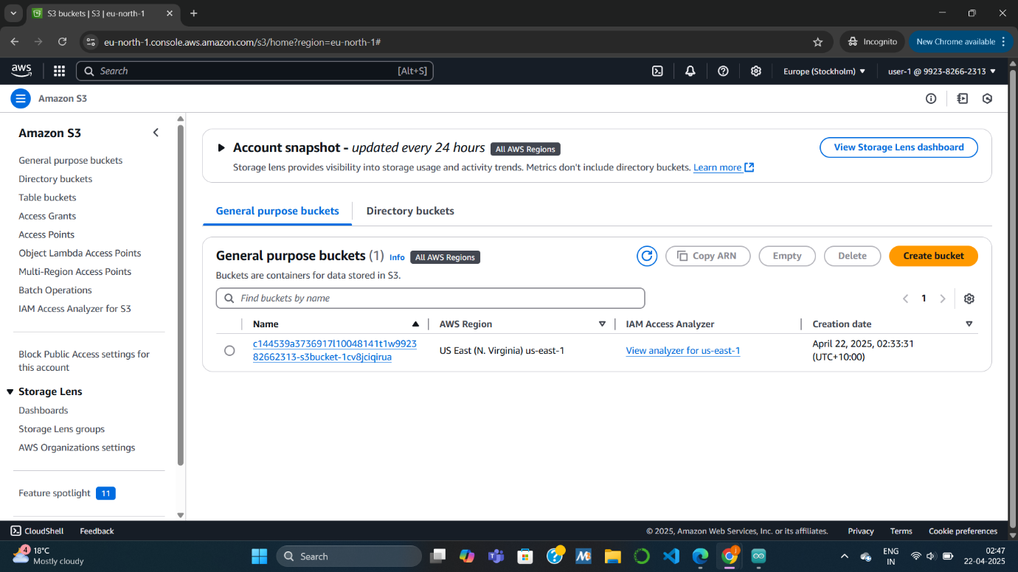

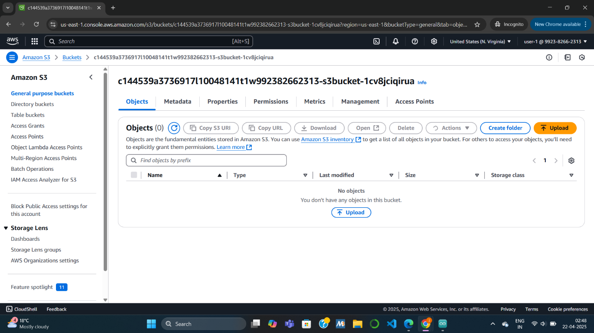

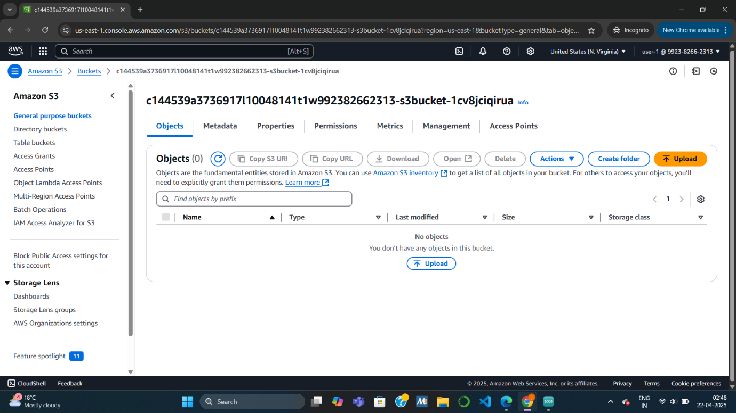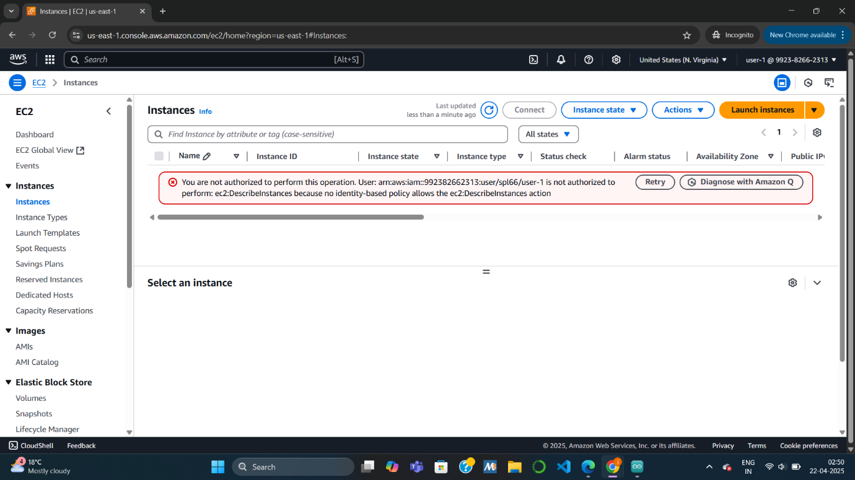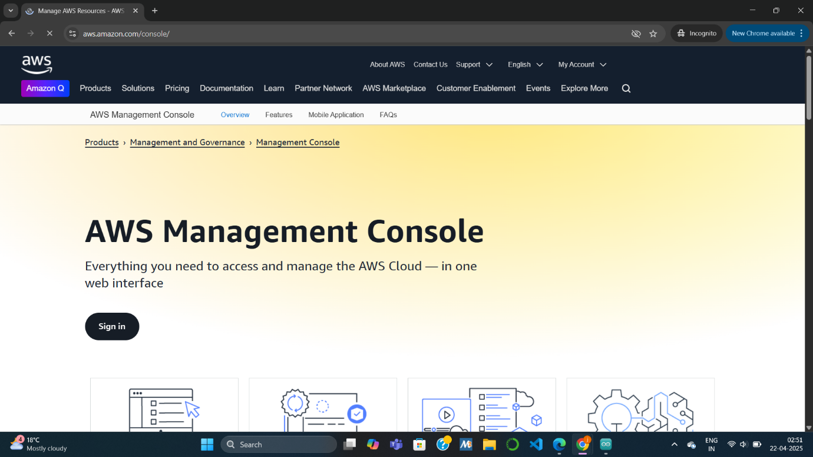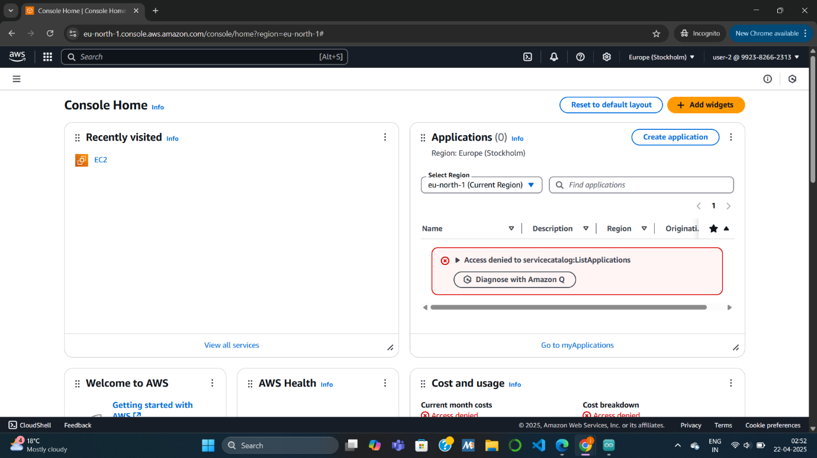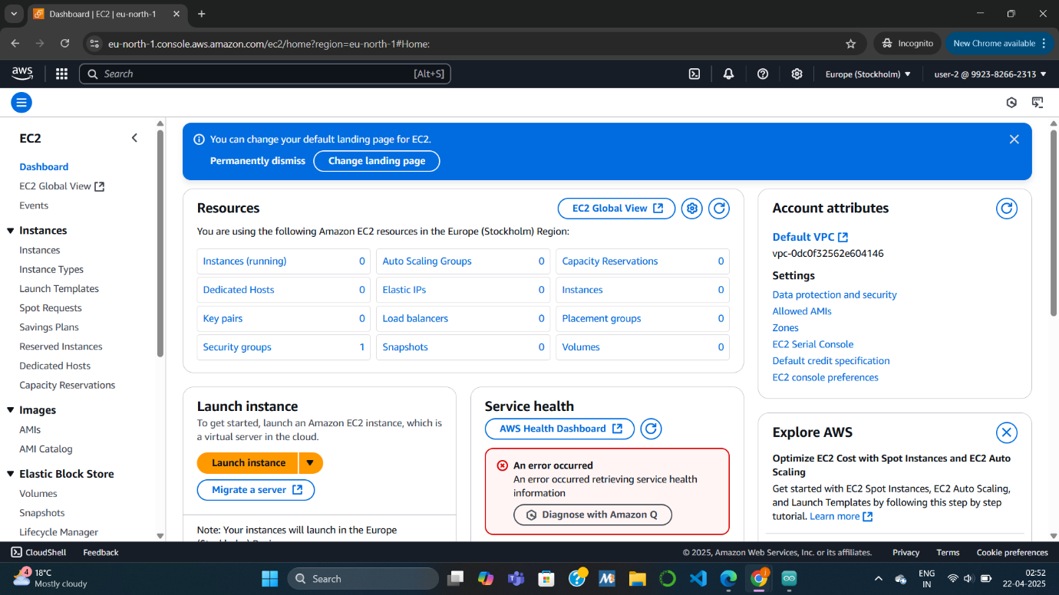

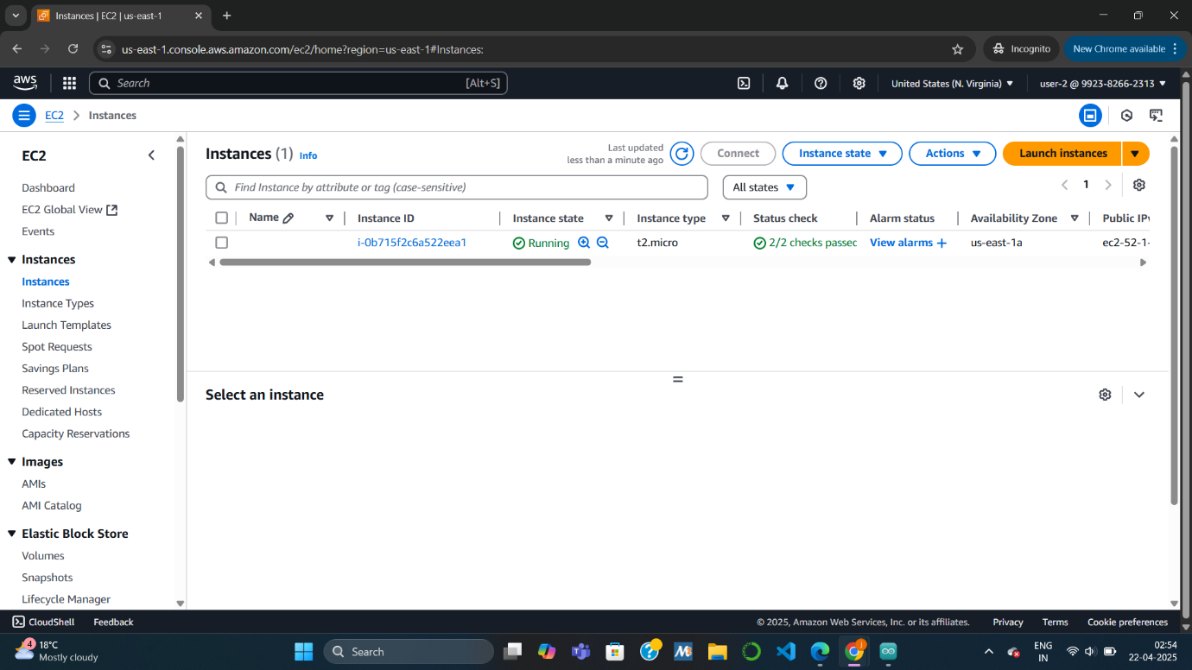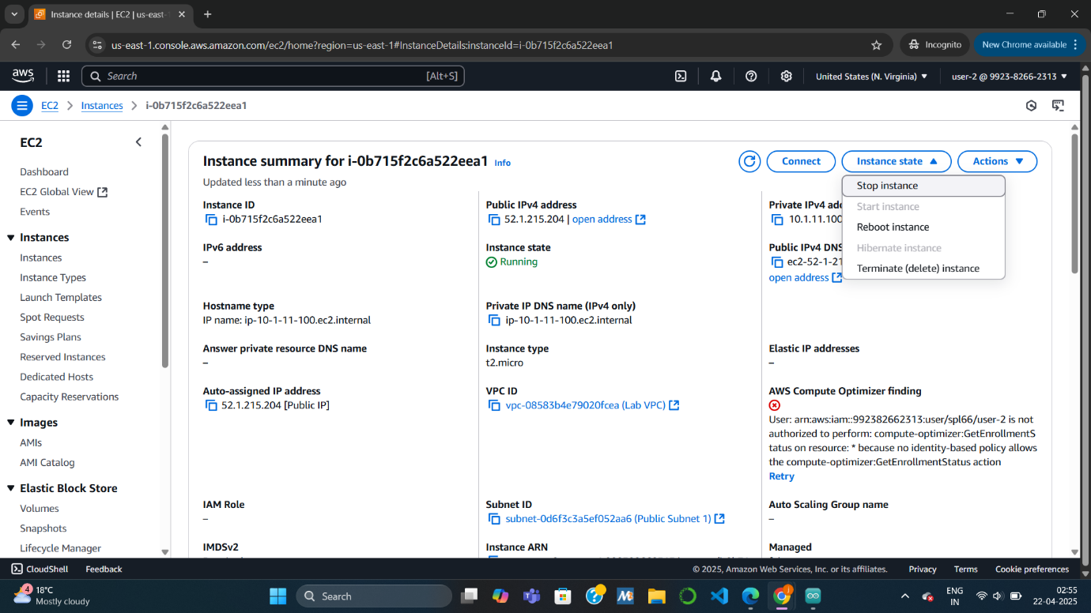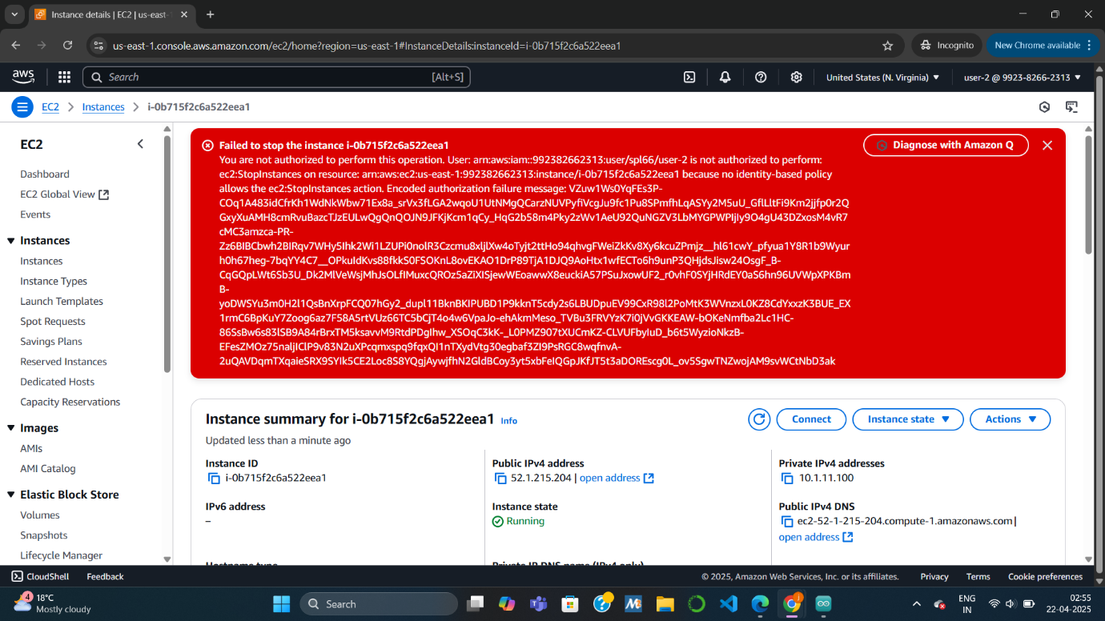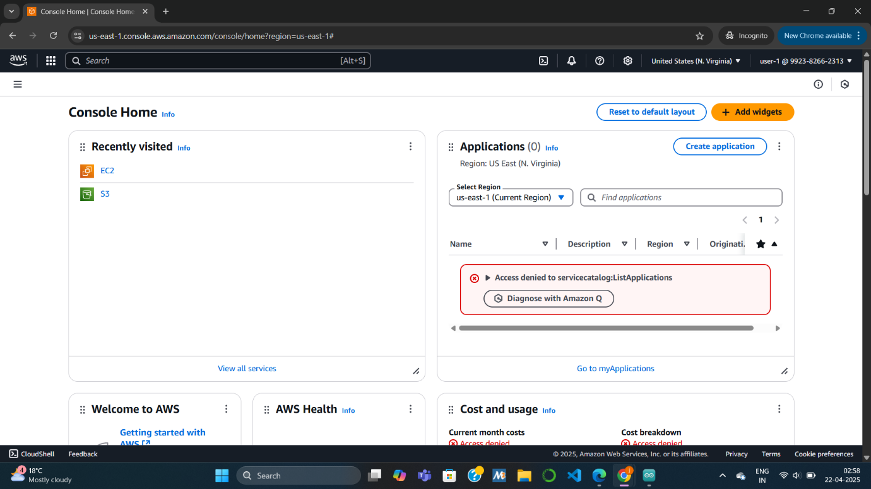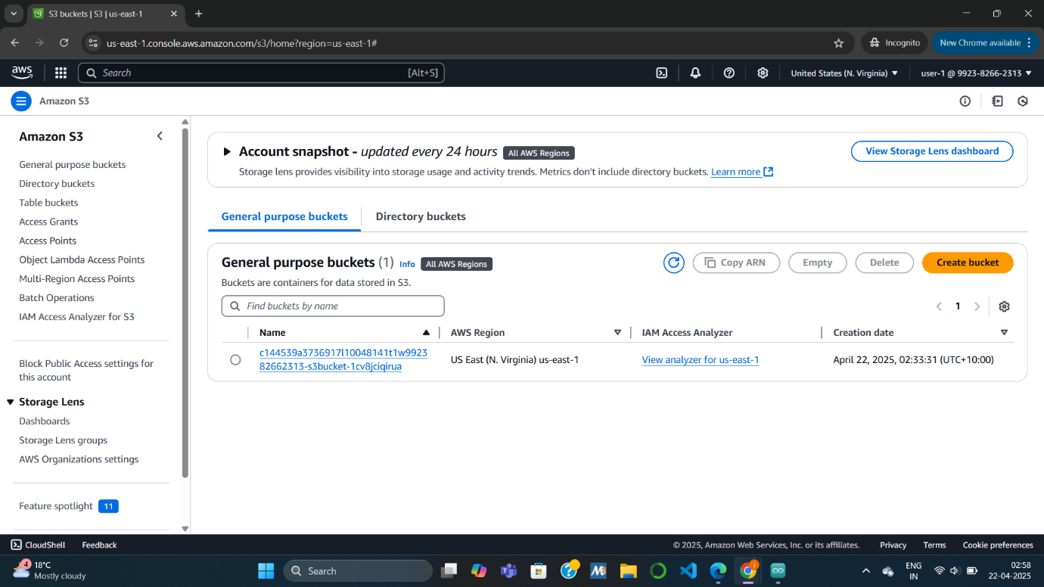

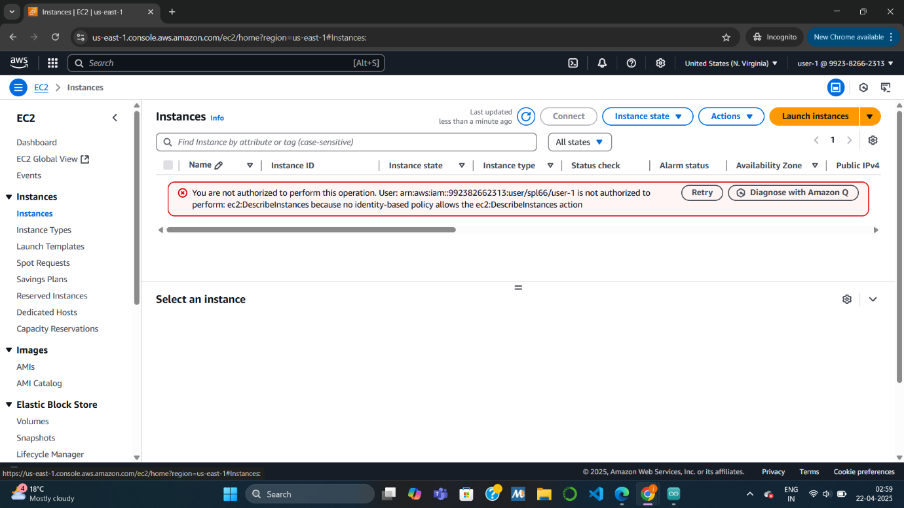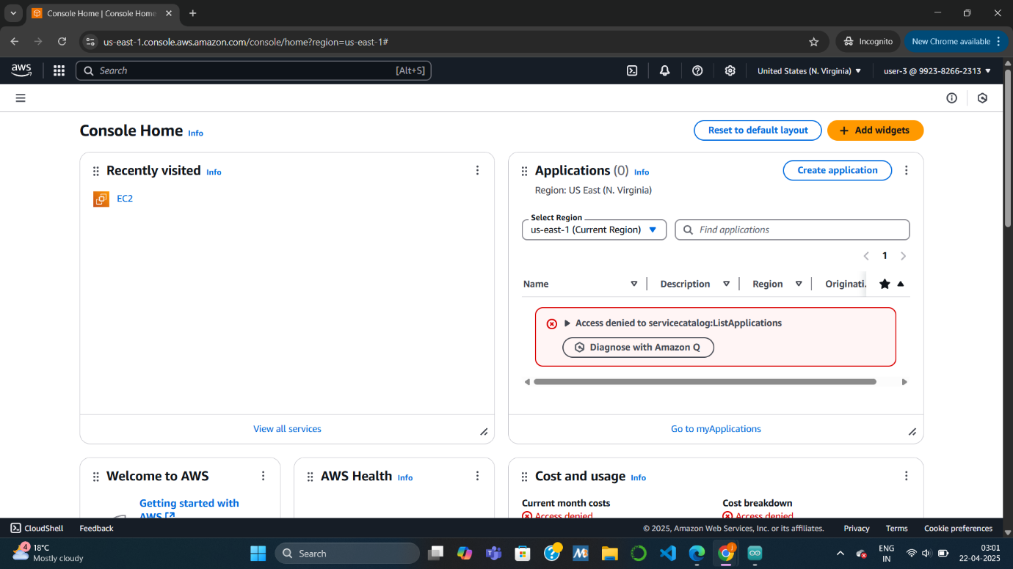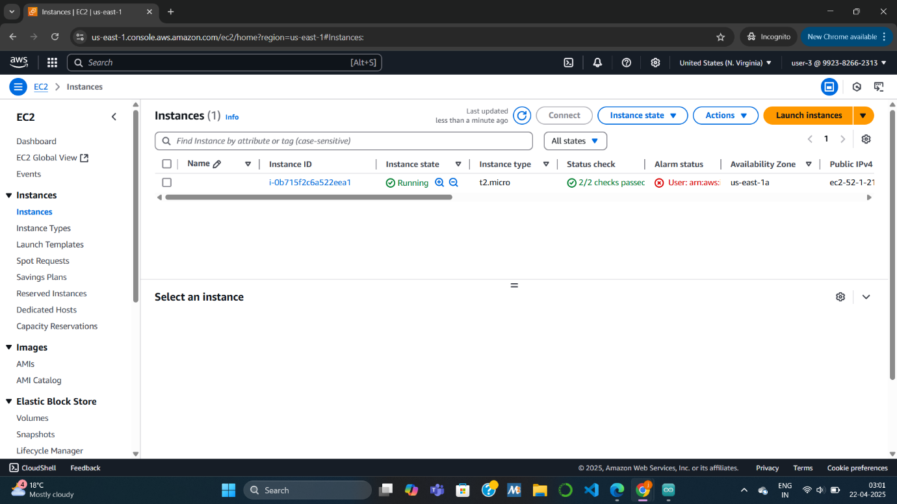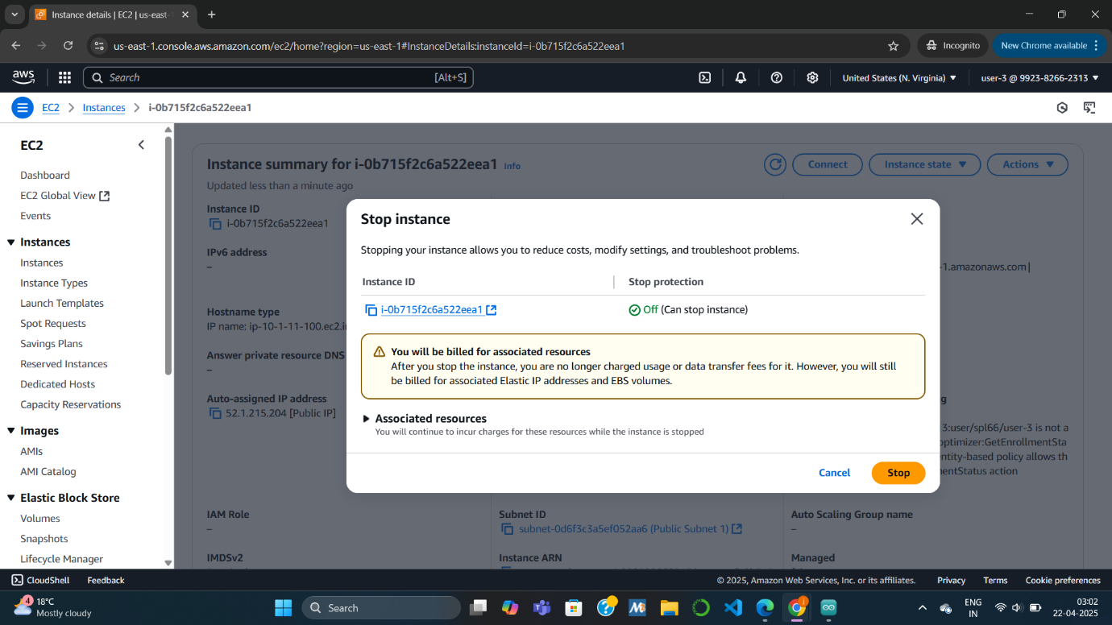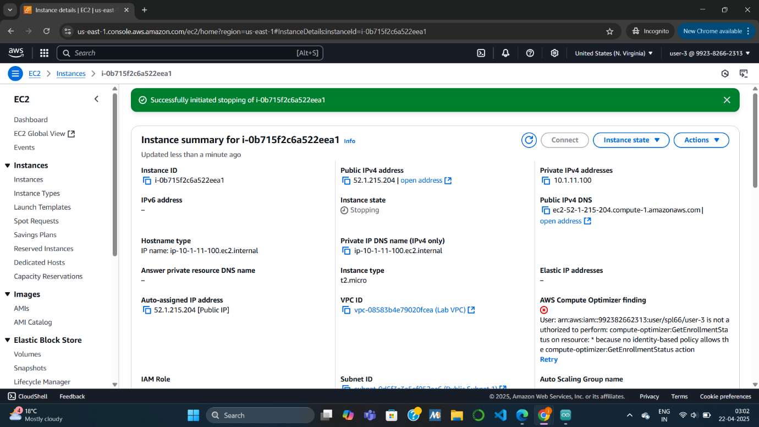

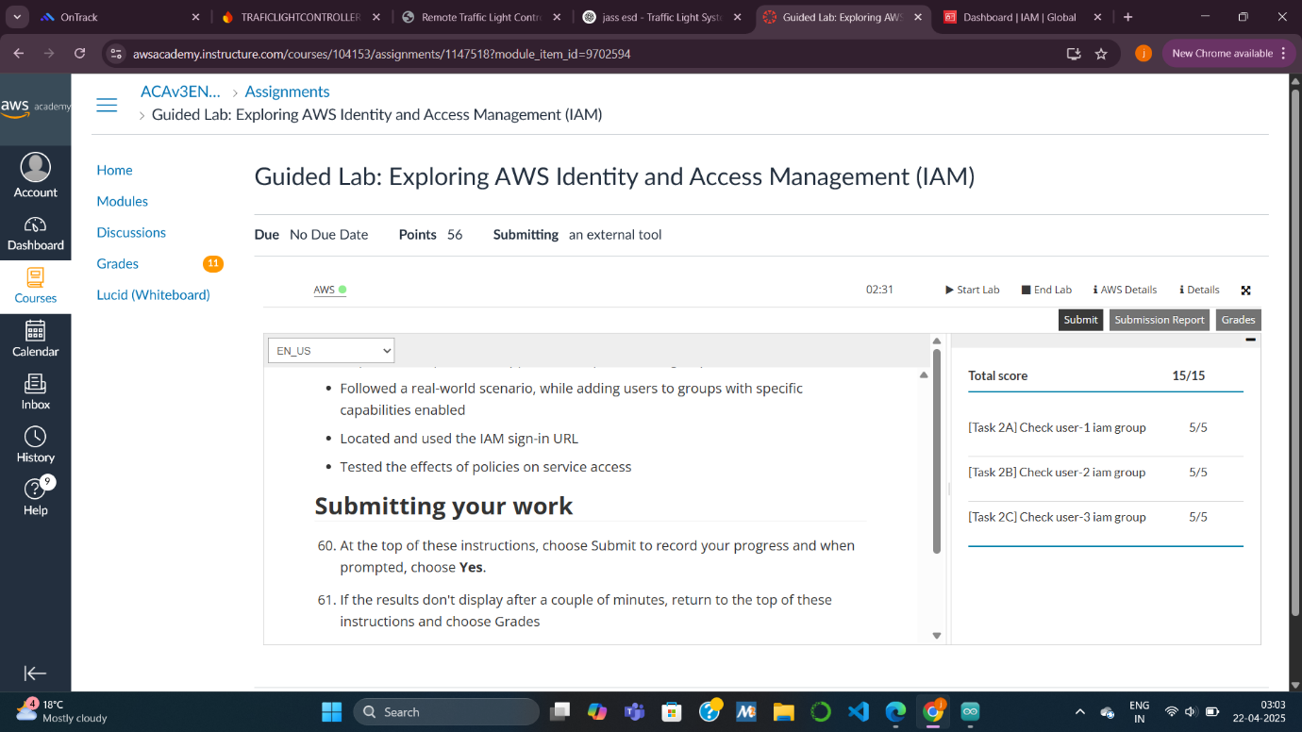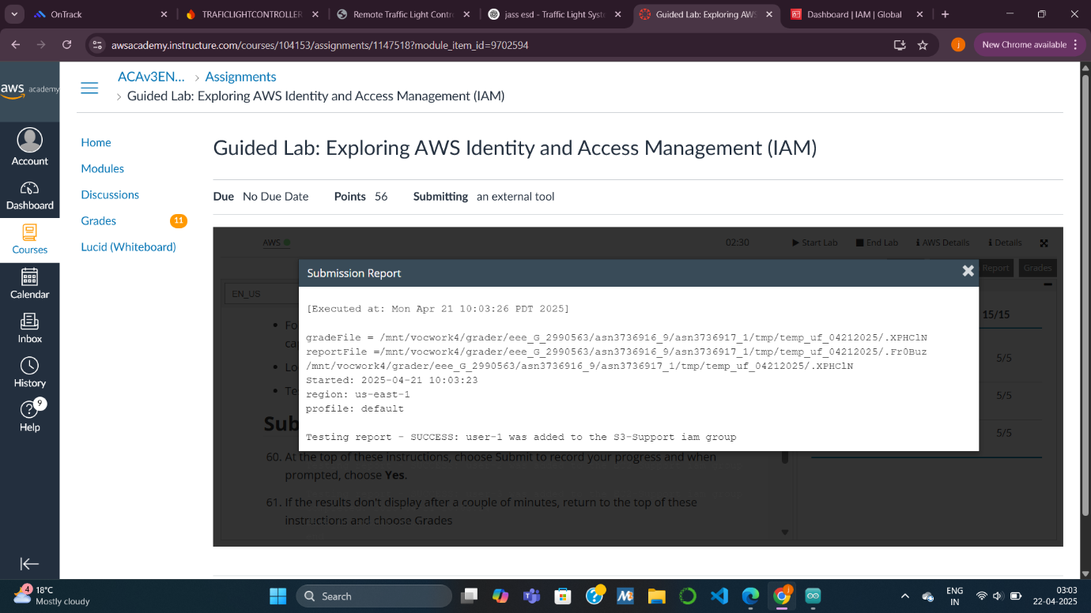

KNOWLEDGE CHECK :

